**DEVELOPMENT OF PROTECTION MECHANISMS FOR SOLAR SYSTEMS AGAINST OVERVOLTAGE**

**BY**

**OLAWUYI TEMITOPE SUNDAY CE20220100399**

**ADEDEJI PELUMI AREMU CE20220100516**

**ADESIPO AYOMIDE CE20220102166**

**AMINU MUSTAPHA OLALEKAN CE20220102172**

**SUPERVISED BY**

**ENGR O. A. OJO**

**CHAPTER ONE**

**INTRODUCTION**

**1.1 Background of the study**

Overvoltage protection is a critical component in the design and operation of solar photovoltaic (PV) systems. Solar power systems are particularly vulnerable to overvoltage, which can arise due to transient surges, lightning strikes, grid faults, or fluctuations in the PV system itself. When exposed to overvoltage conditions, PV modules and associated electronics risk damage, reduced efficiency, or complete system failure. Effective protection mechanisms mitigate these risks, ensuring both the longevity and reliability of solar systems. (Morales-Espana *et al*., 2020).

Overvoltage in PV systems can be categorized into internal and external causes. Internal sources include switching surges and load shedding, which generate temporary high-voltage conditions in the inverter and other electronic components. External sources include lightning strikes, which induce surges that travel through the solar array, and grid-side overvoltage, resulting from faults in the distribution network. According to Morales-Espana et al. (2020), grid-side faults are particularly impactful on large-scale solar farms that are directly connected to the grid. Transient overvoltage can lead to insulation degradation, resulting in reduced lifespan or operational efficiency of PV modules.

Protection strategies in solar systems typically utilize Surge Protection Devices (SPDs) and overvoltage relays to address transient and sustained overvoltage, respectively. SPDs are the most widely used devices; they divert excess energy to the ground, safeguarding critical components. In their study, Al-Sumaiti et al. (2021) highlight the importance of incorporating SPDs with fast response times to handle transients effectively. SPDs are usually installed at multiple points, including the DC side of the PV array, AC output from the inverter, and at critical points in the main distribution board.

In addition to SPDs, relays and fuses are commonly employed to disconnect the system in case of sustained overvoltage. These devices work on predetermined voltage thresholds and are widely used in off-grid systems to protect battery banks and other storage systems. Relay-based protection is essential for off-grid PV systems, as these systems lack the grounding facilities present in grid-tied systems, making them more susceptible to severe overvoltage effects. However, Zhang and Li (2019) found that relays alone might be insufficient due to their slower response time in handling transients, particularly in areas with frequent lightning strikes or erratic weather patterns.

Recent advancements in overvoltage protection focus on enhancing SPD technology, incorporating artificial intelligence (AI) for predictive maintenance, and developing hybrid protection systems. Hybrid protection combines SPDs, relays, and current-limiting technologies to form a multi-layered defense. AI-based predictive models can preemptively identify potential overvoltage events, thus enabling automated activation of protection devices. Ghorbani et al. (2023) describe a hybrid model that utilizes machine learning algorithms to analyze system data and identify patterns that precede overvoltage incidents.

Microgrid applications of PV systems present a unique set of challenges for overvoltage protection, particularly in regions with unreliable grid connections. Research by Liang and Chen (2022) indicates that combining adaptive SPDs with smart grid technology can significantly enhance system resilience against overvoltage. Adaptive SPDs are able to adjust their response characteristics in real-time, adapting to changes in the system’s operating environment.

* 1. **Statement of Problem**

Solar photovoltaic systems (PV) are increasingly used globally due to their renewable energy potential. However, they are highly vulnerable to overvoltage events, which can compromise efficiency, longevity, and reliability. Standard protection mechanisms like surge protection devices (SPDs), relays, and fuses are inadequate for handling complex voltage surges and lack predictive capabilities. Advanced overvoltage protection solutions, incorporating modern technology could offer improved performance and resilience. This study aims to develop effective, adaptive, and intelligent overvoltage protection mechanisms that can respond swiftly to diverse overvoltage conditions, safeguarding solar PV systems.

* 1. **Aim and Objectives of the Study**

The aim of this study is to develop protection mechanisms for solar systems against overvoltage. The specific objectives are to:

1. develop protection mechanisms for solar inverter systems against overvoltage
2. implement the developed system
3. test the implemented system.
   1. **Significance of the Study**

Overvoltage events, often due to lightning strikes or grid anomalies, can lead to sudden downtime, affecting the stability and continuity of power generation. Enhanced overvoltage protection mechanisms ensure that solar systems maintain stable operations, reducing interruptions and promoting a reliable energy supply.

In addition, repeated exposure to transient overvoltages gradually degrades system components, reducing their operational lifespan. Effective protection systems can limit this wear and tear, allowing PV modules, inverters, and battery systems to function optimally over extended periods. This longevity is crucial for achieving a favorable return on investment and reducing maintenance costs.

**1.5 Scope of the Study**

This study seeks to develop a protection mechanism for solar inverter systems against overvoltage. This involves developing the protection mechanism system, implementing the system and testing the performance of the system.

**CHAPTER TWO**

**LITERATURE REVIEW**

**2.1 Solar Inverter**

Solar energy is an abundant and renewable source of power that has gained significant attention due to its environmental benefits and potential to reduce dependence on fossil fuels. One of the critical components in a solar photovoltaic (PV) system is the solar inverter (Akbarzadeh, A., & Wadowski, T. 2014). The primary function of a solar inverter is to convert the direct current (DC) generated by the solar panels into alternating current (AC), which is the standard form of electricity used by most household appliances and the power grid (Hantila, F., & Popescu, F. 2016).

The solar inverter system is a critical component of modern solar PV installations, enabling efficient energy conversion, grid integration, and performance monitoring. With the increasing adoption of solar power worldwide, continued research and development in solar inverter technology are essential to maximizing the efficiency and reliability of solar energy systems.

**2.1.1 Importance of Solar Inverter Systems**

1. **Energy Conversion**: Solar panels generate electricity in the form of DC, but homes and businesses typically use AC. A solar inverter bridges this gap by converting the generated DC to AC, making solar energy usable for typical consumption purposes (Mujtaba, G., *et al* 2021). Without an efficient inverter, the electricity produced by solar panels cannot be used or fed into the grid.
2. **Efficiency and Power Optimization**: Modern solar inverters play a vital role in optimizing the performance of solar power systems. They manage the voltage and current from the panels to maximize energy harvest, using technologies like maximum power point tracking (MPPT). This allows the system to adapt to varying sunlight conditions and ensures optimal energy production throughout the day.
3. **Grid Integration**: Solar inverters also play a key role in grid-connected systems by managing the synchronization between solar power and the electrical grid. Inverter systems ensure that the AC electricity produced is in phase with the grid's voltage and frequency standards (Wang and Zhang, 2020). This helps in exporting excess electricity back to the grid under net metering agreements or feeding into energy storage systems for later use.
4. **Monitoring and Safety**: Inverters often come with built-in monitoring capabilities to track the performance of the solar array. They also provide critical safety functions such as detecting electrical faults, performing automatic shutdowns during grid outages (anti-islanding), and protecting the system from potential hazards.

**2.1.2 Types of Solar Inverters**

There are different types of solar inverters available based on the application and system design:

**1. String Inverters**

String inverters are the most common type of inverter used in residential and small commercial solar systems. In a string inverter setup, multiple solar panels are connected together in series to form a "string." The string's combined DC power is then sent to a single inverter, which converts the DC to AC (Khan, F. A., & Saeed, M. A. 2019).

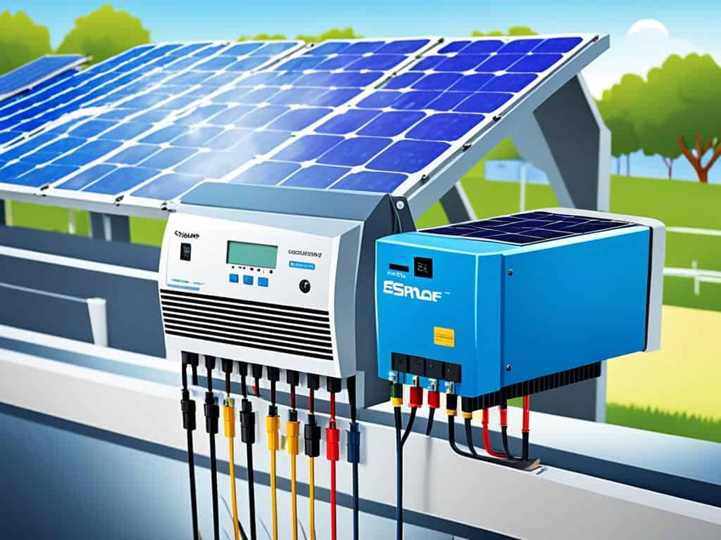

Figure 2.1: Solar String Inverter

**Advantages**:

* 1. Cost-effective for small to medium-sized installations.
  2. Simple design and easy to install.
  3. Centralized conversion and monitoring.

**Disadvantages**:

* 1. Performance is affected by shading or panel malfunction in any one panel since all panels in the string are connected in series.
  2. The entire system depends on the single inverter; if the inverter fails, the entire system stops producing power.
* **Applications**: Primarily used in residential and small to medium-sized commercial installations with uniform sun exposure.

**Example**: A home with a rooftop solar system that has little to no shading is an ideal candidate for a string inverter.

**2. Microinverters**

Unlike string inverters, microinverters are small devices installed on each individual solar panel (Woyte, A., & Nijs, J. 2017). They convert the DC output from each panel directly to AC at the panel level, rather than at a central point.

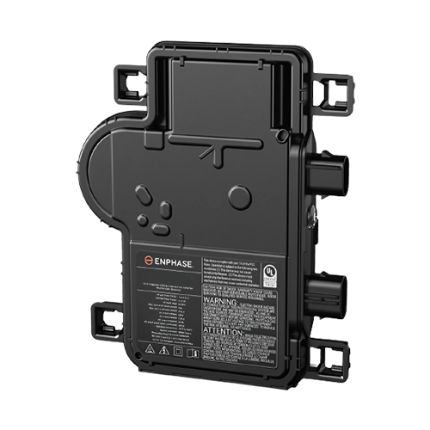

Figure 2.2: IQ8 Microinverter

* **Advantages**:
  + Increased efficiency, particularly in systems where shading or different panel orientations are present.
  + Independent operation of each panel, meaning that shading or failure of one panel doesn’t affect the performance of the others.
  + More granular monitoring and better performance tracking.
* **Disadvantages**:
  + Higher upfront cost compared to string inverters.
  + More complex installation and higher maintenance costs due to the presence of multiple inverters.
* **Applications**: Ideal for residential systems with partial shading or complex roof layouts where panels face in different directions.

**Example**: A rooftop solar system installed on a home with trees that cause partial shading throughout the day would benefit from microinverters.

**3. Power Optimizers**

Power optimizers are often used in conjunction with string inverters. They are installed on each panel to optimize the DC power output before sending it to a central inverter for DC-to-AC conversion (Guerriero and Rossi, 2020). They are similar to microinverters in their ability to handle shading and individual panel performance, but the actual inversion takes place centrally.

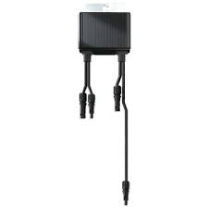

Figure 2.3: Solar Edge S500 Power Optimizer

* **Advantages**:
  + Mitigates performance losses due to shading or soiling of individual panels.
  + Allows for panel-level monitoring.
  + More cost-effective than microinverters while offering similar performance advantages.
* **Disadvantages**:
  + Still dependent on the central string inverter; if the central inverter fails, the entire system goes down.
  + More components to install compared to a traditional string inverter system.
* **Applications**: Useful for systems with partial shading or varying panel orientations where full microinverter solutions may be too expensive.

**Example**: A commercial solar system where some panels experience shading during different times of the day could benefit from the use of power optimizers in combination with a central inverter.

**4. Central Inverters**

Central inverters are large-scale versions of string inverters. Instead of multiple small strings feeding into several small inverters, central inverters handle multiple strings of solar panels, converting a large volume of DC power into AC. Central inverters are typically used in utility-scale solar power plants or very large commercial installations (Hasan, W., & Decker, T. 2018).

* **Advantages**:
  + Highly efficient for large systems.
  + Can handle significant power loads, making them ideal for large-scale projects.
  + Lower cost per watt compared to smaller inverters.
* **Disadvantages**:
  + If the central inverter fails, the entire solar power system is affected.
  + Requires significant space and can be complex to install.
  + Maintenance and repair of large inverters can be costly.
* **Applications**: Utility-scale solar farms and large commercial or industrial installations where cost and efficiency are prioritized over individual panel performance.

**Example**: A solar power plant that supplies electricity to the grid would typically use central inverters to manage the large-scale energy conversion.

**5. Hybrid Inverters**

Hybrid inverters are designed to integrate solar power with energy storage solutions, such as batteries. They are capable of managing both solar power conversion and battery charging, allowing users to store excess solar energy for use during periods of low sunlight or power outages (Li, *et al* 2021).

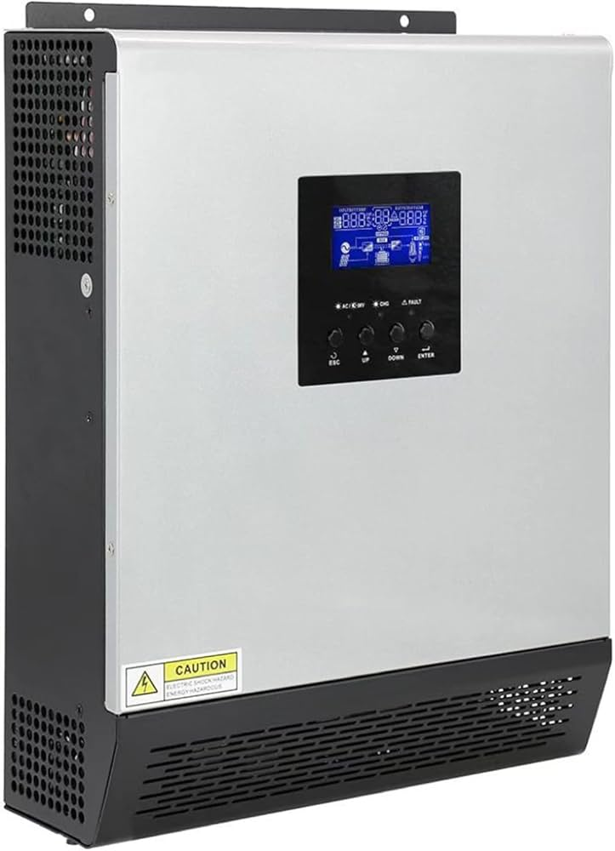

Figure 2.4: Hybrid Solar Inverter

* **Advantages**:
  + Enables energy storage for later use, increasing energy independence.
  + Can be used in both off-grid and grid-tied systems.
  + Provides flexibility in managing energy sources.
* **Disadvantages**:
  + Higher cost compared to standard string inverters.
  + Requires additional equipment, such as batteries, to function fully.
* **Applications**: Used in solar-plus-storage systems, often in homes or businesses that want to store excess energy or function independently from the grid.

**Example**: A home with a solar system and battery storage designed to supply power during grid outages would benefit from a hybrid inverter.

**2.1.3 Technological Advances and Market Trends**

The global push towards renewable energy sources has accelerated the development of advanced solar inverter technologies. Innovations like intelligent grid integration, artificial intelligence-based energy management, and bi-directional inverters that enable energy storage are expanding the functionality of solar inverters. Additionally, the integration of inverters with energy storage solutions is becoming more prevalent, allowing users to store excess solar energy for later use.

The solar inverter market has seen steady growth, driven by favorable government policies, rising environmental awareness, and advancements in PV technology. According to Allied Market Research (2021), the global solar inverter market is expected to grow at a compound annual growth rate (CAGR) of 5.8% from 2021 to 2028 due to the increasing adoption of solar energy across residential, commercial, and industrial sectors.

**2.2 Overvoltage**

Overvoltage refers to a condition in electrical systems where the voltage exceeds the normal operating range. It can arise in both direct current (DC) and alternating current (AC) systems, and poses a significant risk to electrical equipment and infrastructure (Dai and Chen, 2021). When a system experiences overvoltage, components such as insulation, transformers, capacitors, and sensitive electronics can undergo stress, leading to degraded performance, potential failure, or catastrophic damage. Understanding the causes, effects, and mitigation strategies of overvoltage is crucial for reliable and safe system operations (Alaboudy, 2019). The effects of overvoltage vary depending on its magnitude, duration, and frequency. Transient overvoltages can cause immediate damage to insulation materials, electronic devices, and sensitive sensors. These surges can puncture insulation, leading to short circuits, component overheating, or even explosions. Sustained overvoltage, while generally less abrupt, can lead to gradual insulation breakdown, increased thermal stress, and accelerated aging of equipment. In renewable energy systems, such as solar photovoltaic (PV) systems, overvoltage can shorten the lifespan of inverters, batteries, and PV modules. As noted by Mohammadi (2022), repeated exposure to overvoltage events in PV systems can degrade efficiency and ultimately result in system failure.

**2.2.2 Causes of Overvoltage**

Overvoltage in electrical systems can result from natural events or operational factors, influencing the type, duration, and intensity of the overvoltage and requiring different mitigation approaches. The main causes are discussed below:

1**. Lightning Strikes**: One of the most common causes of transient overvoltage is lightning. Lightning strikes induce powerful surges in electrical systems that travel along power lines, potentially damaging or disrupting power equipment. When lightning strikes a power line or nearby structures, it generates a high-magnitude transient surge that can exceed the normal voltage by several orders. This effect is particularly impactful on overhead transmission lines that lack sufficient protection. Wu (2020) report that lightning-induced overvoltages can travel significant distances along transmission networks, affecting substations and sensitive equipment far from the strike location. Protective devices like surge protection devices (SPDs) are thus critical for mitigating these lightning-induced surges in both grid-connected and off-grid systems. Switching Operations in Power Systems Switching transients are short-duration overvoltages caused by routine operations within the power grid, such as opening or closing circuit breakers, energizing transformers, or switching capacitive or inductive loads. During these operations, the sudden change in electrical current can generate oscillations, leading to a temporary increase in voltage. Particularly in high-voltage systems, switching operations can lead to "switching surges" that propagate through the system and impact nearby devices. As noted by Alaboudy et al. (2019), this type of transient overvoltage is a common risk in industrial systems and in renewable energy applications, where frequent load changes or connection/disconnection of inverters can trigger surges.

**2. Faults and Imbalances:** Grid-side faults, such as short circuits, can result in both transient and sustained overvoltage. When a fault occurs, such as a line-to-ground or phase-to-phase fault, it disrupts the normal voltage balance, potentially causing overvoltage in some parts of the network while leading to undervoltage in others. Such imbalances are particularly problematic in distribution networks, where faults on the high-voltage side can induce overvoltage on the low-voltage side. Research by Dai and Chen (2021) highlights that sustained overvoltage is commonly seen in distribution transformers when faults are improperly managed or when the protection systems fail to operate swiftly.

**3. Resonance Phenomena:** Resonance can occur in electrical systems with both inductive and capacitive elements, causing a build-up of oscillatory voltages. When the inductive reactance matches the capacitive reactance, resonance amplifies the voltage across the circuit, leading to overvoltage. Resonance effects are common in power systems with long transmission lines or distributed generation sources, such as PV systems. Dai and Chen (2021) highlight how resonance-induced overvoltage can be exacerbated by reactive power compensation devices, especially under certain grid conditions.

**4. Unbalanced Loads and Load Shedding:** In systems with unbalanced loads or during load shedding, voltage regulation can be disrupted. The abrupt removal of loads causes temporary surges as the system compensates, which can result in overvoltage in other parts of the network. Zhang and Li (2019) explain that this type of overvoltage often affects off-grid systems or isolated networks, where voltage regulation devices are minimal.

**5. Faults in Distributed Energy Resources (DERs)**: Distributed energy resources (DERs) such as solar PV systems or wind turbines can introduce overvoltage when integrated into the grid, especially during sudden drops in load or under fault conditions. These sources often have inverters that control voltage output, but malfunctions or faults in the inverter can lead to overvoltage at the grid interconnection. Mohammadi et al. (2022) note that PV systems are particularly susceptible to causing localized overvoltage, which can propagate to adjacent systems if not adequately controlled.

**2.2.3 Protection Mechanisms in Solar Inverter Systems**

Protection mechanisms in solar inverter systems are essential for ensuring the system's reliability and safety against overvoltage. Solar inverters, which convert the direct current (DC) from photovoltaic (PV) modules to alternating current (AC), are sensitive to voltage fluctuations that can result in damage, system shutdowns, or even electrical fires. Effective overvoltage protection mechanisms safeguard these systems from transient surges, grid anomalies, and internal overvoltage events, ultimately protecting the entire solar installation. The key protection mechanisms in solar inverters against overvoltage is discussed below:

**1. Surge Protection Devices (SPDs):** Surge protection devices (SPDs) are widely used in solar inverter systems to protect against transient overvoltages, such as those caused by lightning or grid switching operations. These devices divert excess voltage to the ground, preventing high-voltage spikes from reaching sensitive inverter components. SPDs are often installed at multiple points in the system: on the DC side (near the PV array) to guard against surges caused by lightning and on the AC side to protect from grid-induced surges. SPDs are essential for systems in areas with high lightning activity, as they can respond quickly and effectively to sudden voltage spikes (Tang, 2021).

**2. Overvoltage Relays:** Overvoltage relays are designed to protect the inverter against sustained overvoltages by continuously monitoring the system voltage. If the voltage exceeds a pre-set threshold for a certain duration, the relay disconnects the inverter from the grid, preventing potential damage. These relays are particularly useful in areas with grid instability, where sustained overvoltage may be a frequent issue. Advanced overvoltage relays often feature adjustable settings, allowing operators to define response times and voltage limits based on system requirements (Alaboudy, 2019).

**3. Automatic Disconnect Switches:** Automatic disconnect switches are integrated into many modern inverters to detect unsafe voltage conditions and isolate the inverter from the grid or load. If the system detects an overvoltage that surpasses safe levels, the switch activates automatically to disconnect the inverter, effectively protecting it from damage. This feature is often built into the inverter’s internal circuit design, with advanced models enabling reconnection once the voltage normalizes. Disconnect switches are crucial for preventing damage to both inverter and downstream components.

**4. Grounding and Bonding:** Grounding provides a safe path for stray voltage or surges to dissipate into the earth, reducing the risk of overvoltage affecting the inverter. A properly grounded system prevents accumulation of excess voltage, as it redirects any unintentional surge safely. Bonding between components in solar arrays also helps maintain system stability during transient events. Grounding is particularly useful for lightning protection and is essential in larger solar PV systems (Wu, 2020).

**5. Inverter Self-Protection Mechanisms:** Many modern inverters are equipped with self-protection mechanisms, including voltage monitoring, temperature sensors, and software-based algorithms that respond dynamically to overvoltage. These systems continuously check for irregularities and, when triggered, adjust their operation or shut down temporarily. For example, if a voltage surge is detected, the inverter can adjust the Maximum Power Point Tracking (MPPT) operation to reduce power intake, limiting potential damage (Mohammadi, 2022).

**6. Hybrid Protection Systems:** Hybrid protection systems combine SPDs, overvoltage relays, and automatic disconnect switches, offering multi-layered protection against both transient and sustained overvoltage conditions. Hybrid systems provide comprehensive protection by covering multiple scenarios, such as lightning strikes, grid disturbances, and internal inverter faults. By using a combination of devices, hybrid protection ensures that if one mechanism fails, another is available to handle the overvoltage, thus enhancing the overall reliability and resilience of the solar system (Ghorbani, 2023).

**2.3 Components Used**

The following components were used for the development of the protection mechanism for solar inverter systems against short circuit.

**PIC Microcontroller**

Peripheral Interface Controller (PIC) is a family of microcontrollers made by Microchip Technology, derived from the PIC1640 originally developed by General Instrument's Microelectronics Division (Leibson, 2023). The PIC was originally intended to be used with the General Instrument CP1600, the first commercially available single-chip 16-bit microprocessor. The CP1600 had a complex bus that made it difficult to interface with, and the PIC was introduced as a companion device offering ROM for program storage, RAM for temporary data handling, and a simple CPU for controlling the transfers. While this offered considerable power, GI's marketing was limited and the CP1600 was not a success. When the company spun off their chip division to form Microchip in 1985, sales of the CP1600 were all but dead. By this time, the PIC had formed a major market of its own, and it became one of the new company's primary products (Leibson, 2023).

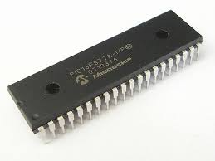

Figure 2.5: PIC Microcontroller

The **microcontroller** is the brain of the protection system, responsible for processing input from sensors and executing control commands. It continuously monitors the system's electrical parameters, such as voltage, current, and temperature. In the event of an anomaly, such as an overcurrent or short circuit, the microcontroller sends a signal to shut down or isolate the affected part of the system (Nicolas, 2017).

**ZMPT101B Voltage Sensor**

The **ZMPT101B** is a popular voltage sensor module used for measuring AC voltage. It is based on the principle of voltage divider and is designed to provide accurate and reliable voltage measurements for various applications, including power monitoring and control systems. The ZMPT101B is primarily used for measuring AC voltages (Sarkar and Halder, 2016). It can be interfaced with microcontrollers, such as Arduino, to provide real-time voltage readings. The module outputs an analog voltage that is proportional to the AC voltage being measured.The sensor operates using a **voltage transformer** to step down the high voltage AC signal to a lower, safer level. This lower voltage is then fed into a precision rectifier circuit that converts the AC voltage into a DC voltage, which is proportional to the original AC voltage. The output DC voltage can be read by an analog-to-digital converter (ADC) connected to a microcontroller.

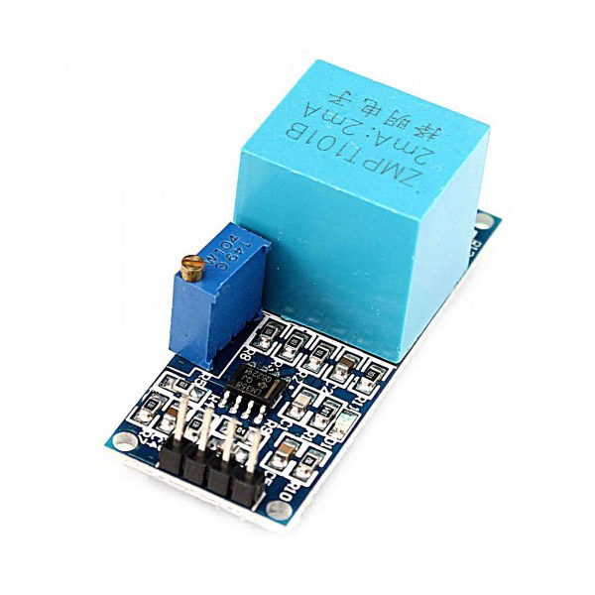

Figure 2.6: ZMPT101B Voltage Sensor

**Relays and Circuit Breakers**

**Relays** and **circuit breakers** are essential components in the protection mechanism, providing isolation and disconnection in case of a short circuit. When the system detects a fault, the relay or circuit breaker is triggered by the microcontroller to disconnect the inverter from the load, preventing further damage (Abdelkader and Hamid, 2014).

**Bypass Diodes**

A **bypass diode** is an essential component in solar photovoltaic (PV) systems, designed to protect solar panels from the adverse effects of partial shading and other faults that can lead to hot spots and power loss. These diodes allow current to bypass a solar cell or a group of solar cells if they become shaded, damaged, or faulty, ensuring the system continues to operate efficiently.Solar panels are made up of multiple interconnected photovoltaic cells (Lorenzo, 2012). When one or more of these cells are shaded or damaged, their electrical output is reduced, causing them to act as resistors. This resistance can lead to:

1. **Power loss**: The entire panel’s performance can be affected by a single underperforming cell.
2. **Hot spots**: The shaded cells dissipate energy as heat, leading to localized overheating, which can damage the solar module.

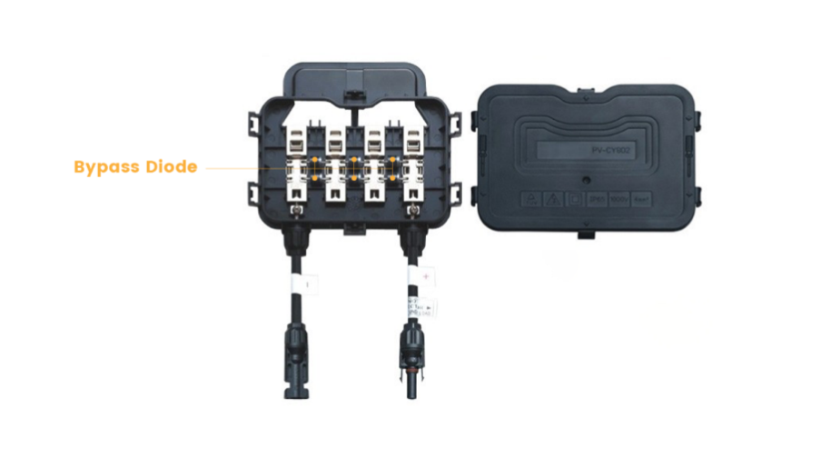

Figure 2.7: Bypass Diode

A bypass diode is connected in parallel with each string of cells in a panel. If a section of the panel becomes shaded, the bypass diode provides an alternative low-resistance path for the current. This allows the unaffected cells to continue generating power while preventing reverse bias across the shaded cells, avoiding damage and minimizing power loss (Sopori, 2011).

**LM35 Temperature Sensor**

The **LM35** is a precision temperature sensor widely used for measuring ambient temperature in various applications. Manufactured by Texas Instruments, the LM35 provides an analog output voltage that is linearly proportional to the temperature in degrees Celsius. It is renowned for its simplicity, accuracy, and ease of interfacing with microcontrollers, making it a common choice for temperature monitoring in electronic systems (Vishay and Park, 2014).

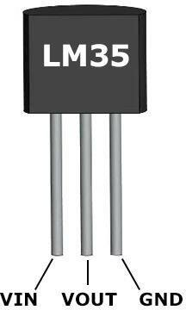

Figure 2.8: LM35 Temperature Sensor

**Key Features and Specifications**

The following are the features and specifications of LM35 according to Smith (2018):

1. **Linear Output**: The LM35 produces a linear voltage output directly proportional to the temperature, making it easy to convert the sensor's readings into temperature values. The output voltage increases by 10 mV for every 1°C rise in temperature.
2. **High Accuracy**: The sensor is factory-calibrated, offering an accuracy of ±0.5°C at room temperature. It can measure temperatures in the range of **-55°C to 150°C**, making it suitable for a wide variety of applications, including industrial and consumer electronics.
3. **Low Power Consumption**: The LM35 operates with very low power, typically consuming less than 60 μA. This makes it ideal for battery-powered and energy-efficient devices.
4. **Wide Operating Voltage**: It can operate from 4V to 30V, allowing it to be easily integrated into various circuits.
5. **Low Self-Heating**: The sensor exhibits low self-heating, which ensures that the temperature measurements are accurate and not influenced by the device’s own heat dissipation.

**Working Principle**

The LM35 operates on the principle of **analog voltage output.** The temperature-sensitive silicon bandgap circuit inside the sensor generates an output voltage that is directly proportional to the temperature being measured. This voltage can be read by an **Analog-to-Digital Converter(ADC)** on a microcontroller, and with a simple conversion, the temperature can be calculated (Kumar, 2017)).

Since the LM35 outputs in Celsius, there’s no need for external calibration, making it highly convenient for users who need direct Celsius measurements. For example, at 25°C, the output is 250 mV, which can be easily interpreted by the connected microcontroller (Smith, 2018).

**Zener Diodes**

A **Zener diode** is a type of semiconductor device that allows current to flow in the forward direction like a typical diode but can also conduct in reverse once a specific breakdown voltage (called the **Zener voltage**) is reached. Unlike regular diodes, Zener diodes are designed to operate in the **reverse breakdown region** without being damaged, making them highly useful for voltage regulation and protection in electrical circuits (Lal, 2017).

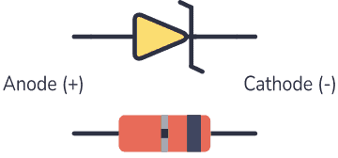

Figure 2.9: Zener Diode

### Working Principle

The key function of a Zener diode is based on the **Zener breakdown** phenomenon. When the reverse voltage applied to the diode exceeds its Zener voltage, it causes a breakdown in the diode’s junction. This allows the diode to conduct current in the reverse direction, maintaining a stable voltage across the diode equal to the Zener voltage. The Zener diode essentially acts as a voltage clamp or voltage regulator, ensuring that the voltage across its terminals does not exceed a predetermined level (Horowitz and Hill, 2015).

1. **Forward bias**: In forward bias, the Zener diode behaves like a regular diode, conducting current once the forward voltage threshold (typically around 0.7V for silicon diodes) is exceeded.
2. **Reverse bias**: When reverse biased, the Zener diode does not conduct until the reverse voltage exceeds the Zener voltage, at which point the diode begins to conduct in reverse and maintains a stable voltage equal to its Zener voltage (Rashid, 2011).

**Transistors**

A **transistor** is a semiconductor device that can act as an amplifier, switch, or signal modulator. It is one of the most important building blocks of modern electronic circuits, used in everything from small logic gates to complex integrated circuits (ICs). Transistors have revolutionized electronics, replacing vacuum tubes due to their smaller size, lower power consumption, and higher reliability (Bowers, 2017).

**Types of Transistors**

The following are the types of transistors according to Sedra and Smith, (2010)

1. **Bipolar Junction Transistor (BJT)**:

**Structure**: A BJT consists of three layers of semiconductor material: either NPN or PNP.

**Operation**: BJTs control current by applying a small current to the base, which allows a larger current to flow between the collector and the emitter. They are current-controlled devices.

**Applications**: BJTs are used in amplifiers, oscillators, and switching circuits.

1. **Field-Effect Transistor (FET)**:

**Structure**: FETs have three terminals: the gate, drain, and source. Unlike BJTs, FETs use an electric field to control the flow of current.

**Types**:**Junction FET (JFET)**:

The simplest type, with the current flowing from the source to the drain controlled by the voltage applied to the gate.

**Metal-Oxide-Semiconductor FET (MOSFET)**: One of the most common transistors in digital circuits due to its efficiency and high switching speed. MOSFETs are classified into N-channel and P-channel types.

**Applications**: FETs are widely used in integrated circuits (ICs), especially MOSFETs in computers and digital electronics.

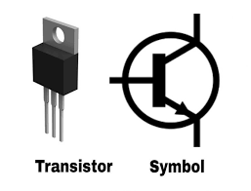

Figure 2.10: Zener Diode

### Working Principle

A transistor works by controlling the flow of current between two terminals (collector and emitter for BJTs, drain and source for FETs) using a third terminal (base for BJTs, gate for FETs). In a BJT:

* **NPN Transistor**: When a small current flows into the base, it allows a larger current to flow from the collector to the emitter.
* **PNP Transistor**: The base current controls the larger current flowing from the emitter to the collector, but in reverse polarity compared to the NPN type.

In FETs, the gate voltage controls the conductivity of the channel between the drain and source, effectively acting as a switch or amplifier (Horowitz and Hill, 2015).

**LED**

When current passes through a light-emitting diode (LED), a semiconductor device, light is released. Recombining electrons and electron holes in the semiconductor results in the release of energy in the form of photons. The energy needed for electrons to pass through the semiconductor's band gap determines the hue of the light, which corresponds to the energy of the photons. A layer of light-emitting phosphor or several semiconductors can be used to create white light on a semiconductor device (Edwards, 2019).The first LEDs, which debuted as useful electrical components in 1962, released low-intensity infrared (IR) light. Remote-control circuits, such as those used with a variety of consumer gadgets, use infrared LEDs. The early LEDs that produced visible light were dim and only produced red light.

LEDs have many advantages over incandescent light sources, including lower power consumption, longer lifetime, improved physical robustness, smaller size, and faster switching. In exchange for these generally favorable attributes, disadvantages of LEDs include electrical limitations to low voltage and generally to DC (not AC) power, inability to provide steady illumination from a pulsing DC or an AC electrical supply source, and lesser maximum operating temperature and storage temperature (Okon & Biard, 2015).

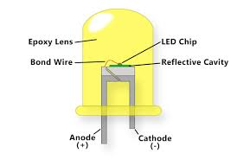

Figure 2.11: LED

**2.4 Review of related works**

Previously, Mouftah (2011) worked on construction and implementation of 50 Watt inverter. It was found that, the production of solid state inverters which provides environmentally friendly alternating for un-interruptible power supply for the working of different gadgets and for suitable economy. It was further revealed that, this study is thus anchor on this makeup 50watt inverter. For provision of power using locally sources 25Ah 12colts deep cycle batting. Oscillator determined MOSFETs and a transformer along with other electronic components. In building an inverter for the conversation of direct current (DC) to alternating currents (AC) at a normal frequency of 10HZ, due consideration is given to the switching speed of the oscillator used to make sure that the MOSFETs in their two channels operates in their saturation and cut-off state when appropriately driven by oscillator outputs in a way to complement each other.

Sheetal et al. (2023) presented a paper on SOLAR-PV inverters for the overall stability of power systems with intelligent MPPT control of DC-link capacitor voltage. This paper demonstrates the controlling abilities of a large PV farm as a Solar-PV inverter for mitigating the chaotic electrical, electromechanical, and torsional oscillations including Subsynchronous resonance in a turbogenerator-based power system. The oscillations include deviations in the machine speed, rotor angle, voltage fluctuations (leading to voltage collapse), and torsional modes. During the night with no solar power generation, the PV plant switches to PV-STATCOM mode and works as a Solar-PV inverter at its full capacity to attenuate the oscillations. During full sun in the daytime, on any fault detection, the PV plant responds instantly and stops generating power to work as a Solar-PV inverter. The PV-farm operates in the same mode until the oscillations are fully alleviated. This paper manifests the control of the DC-link capacitor voltage of the Solar-PV inverter with a bacterial foraging optimization-based intelligent maximum power point tracking controller for the optimal control of active and reactive power. Kundur’s multi-machine model aggregated with PV-plant is modeled in the Matlab/Simulink environment to examine the rotor swing deviations with associated shaft segments. The results for different test cases of interest demonstrate the positive outcomes of deploying large PV farms as a smart PV-STATCOM for controlling power system oscillations.

Also, Apeh and Olaye(2010) worked on design and construction of 100-watt power inverter. It was revealed that, electricity has great control over the most daily activities for instance in domestic and industrial utilization of electric power for operation. The result shown that, electricity can be generated from public support to different ways including the use of water, wind and steam energy to drive the turbine as well as more recently the use of gas generator astral energy and nuclear energy are as well source of electricity.

**CHAPTER THREE**

**METHODOLOGY**

**3.1 System Design**

The design of protection mechanisms for solar inverters against overvoltage is vital to enhancing the safety, reliability, and efficiency of solar PV systems. By integrating advanced detection, isolation, and recovery techniques, the system ensures that short circuits are managed effectively, minimizing downtime and preventing damage to the inverter and other components.

**3.2 System Architecture**

The system consists of several interconnected modules:

1. **Solar Panels (PV Array)**: The primary energy source feeding DC power to the inverter.
2. **Inverter**: Converts DC to AC and includes monitoring, control, and protection modules.
3. **Protection Mechanisms**: Integrated safety devices and algorithms that detect and isolate short circuits.
4. **DC Input Protection:** This protect against overcurrent from the solar panels and the devices includes fuses, circuit breakers and surge protection devices.
5. **Grid Connection**: Optional grid tie for excess energy export and grid support

**Solar Panels**

**DC Input Protection**

**Solar Inverter**

**Grid Connection**

**Protection Mechanism**

3.1: System Block Diagram

**3.2.1 Solar Panels**

Solar panels are made up of many individual solar cells, typically composed of silicon, which is a semiconductor material as shown in figure 3.1. When sunlight strikes these cells, it excites electrons, creating a flow of electric current through the material. This process is known as the photovoltaic effect. The electricity generated is direct current (DC), which is then converted to alternating current (AC) by an inverter for use in homes and businesses.

**3.2.2 DC Input Protection**

DC input protection is a crucial aspect of solar inverters, designed to safeguard the system from potential damage caused by overcurrent, voltage spikes, and other electrical faults. Protecting the DC input section is essential to ensure the longevity and reliability of solar power systems. The key components used are fuses, circuit breakers and surge protection devices (SPDs).

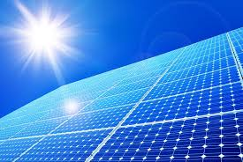

Figure 3.2: Solar Panels

1. **Fuses**: Designed to break the circuit in case of overcurrent conditions. They are cost-effective but require replacement once blown.
2. **Circuit Breakers**: Automatically disconnect the circuit during overload or short circuit events. They can be reset after a fault, making them more convenient for continuous operations
3. **Surge Protection Devices**: SPDs protect the inverter and connected components from voltage spikes caused by lightning strikes or switching surges in the electrical grid. They divert excess voltage away from sensitive equipment, preventing damage.

**3.2.2 Solar Inverter**

A solar inverter is a crucial component in photovoltaic (PV) systems, converting the direct current (DC) generated by solar panels into alternating current (AC) for use in homes and businesses. In addition to this primary function, solar inverters employ Maximum Power Point Tracking (MPPT) to optimize energy harvest and include protective features to ensure safety and reliability.

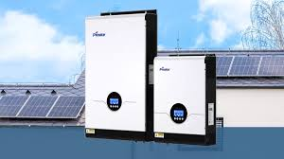

Figure 3.3: Solar Inverter

**3.2.3 Protection Mechanisms**

Protection mechanisms against overvoltage in solar inverters are essential for maintaining system reliability, safety, and efficiency. Overvoltage, caused by factors like lightning, grid fluctuations, or load switching, can damage sensitive inverter components and compromise overall system performance.

i. **Surge Protection Devices (SPDs)**: SPDs are essential for shielding inverters from transient overvoltages, such as lightning-induced surges. These devices divert excess voltage to the ground, preventing it from reaching and damaging critical inverter components. SPDs were installed on both the DC side (near the PV array) and the AC side (at the grid connection), protecting against external and internal voltage surges.

ii. **Overvoltage Relays**: Overvoltage relays continuously monitor system voltage and automatically disconnect the inverter if voltage exceeds safe limits for a sustained period. This is used to protect the inverter from prolonged overvoltage conditions by isolating it from the source until normal conditions are restored.

iii. **Automatic Disconnect Switches**: Many modern inverters include automatic disconnect switches, which instantly isolate the inverter when unsafe voltage levels are detected. This mechanism prevents voltage spikes from entering the inverter, thus protecting sensitive components.

iv. **Grounding and Bonding**: Grounding provides a safe path for voltage surges to dissipate into the earth, while bonding ensures that all system components maintain a stable voltage. This method is used to prevent transient overvoltage, especially lightning strikes, reducing the impact on the inverter.

* 1. **Solar Grid Connection**

Connecting a solar power system to the grid involves several steps to ensure safety, compliance with regulations, and optimal performance. The diagrammatic illustration of the grid connection is shown in figure 3.3. The used are highlighted as follows:

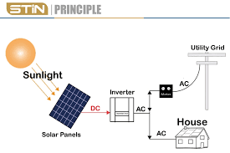

Figure 3.4: Solar Grid Connection

1. The energy consumption was determined by analyzing utility bills to decide the size of the solar system required.
2. Suitable solar panels, inverters, and other components were selected. Ensuring the inverter is grid-tied and compatible with your solar array.
3. A layout for the solar panels was created considering orientation and tilt for maximum sunlight exposure. Ensure the design accounts for electrical and safety codes.
4. The solar panels were mounted on the designated roof, ensuring they are securely attached and positioned for optimal sun exposure.
5. The inverter was positioned close to the solar panels and the main electrical panel to minimize energy loss. Ensuring it is in a well-ventilated area to prevent overheating.
6. DC wiring was run from the solar panels to the inverter and connect the inverter’s AC output to your electrical panel.
7. All necessary protective devices were installed to safeguard the system.
8. The connection was checked before submitting for grid connection approval/
9. Once all approvals are obtained, the system was connected to the grid. This involves the utility company installing a bi-directional meter to measure energy consumption and production.

**3.4 Working Principle of the Protection Mechanisms for Solar Inverter Systems**

The protection mechanisms in solar inverters operate based on different principles to detect and mitigate overvoltage events, ensuring system stability and protecting inverter components from damage. These mechanisms include surge protection devices, overvoltage relays, automatic disconnect switches, grounding, and internal inverter protections

**1. Surge Protection Devices (SPDs)**

**Working Principle:** SPDs work by diverting excess voltage away from sensitive inverter **components. They utilize components like metal oxide varistors (MOVs) or gas discharge tubes (GDTs) that exhibit high resistance under normal voltage but rapidly change to low resistance when voltage surges above a set threshold.**

**Operation: When a transient overvoltage event, such as a lightning strike, occurs, the SPD directs the excess voltage to the ground, preventing it from entering the inverter. Once the surge dissipates, the SPD returns to its high-resistance state, allowing normal operation to continue.**

**2. Overvoltage Relays**

**Working Principle: Overvoltage relays continuously monitor the system voltage and respond when it exceeds a pre-set threshold for a certain duration, typically a few milliseconds to seconds.**

**Operation: If the relay detects sustained overvoltage, it triggers a response mechanism that disconnects the inverter from the grid or load. These relays are programmable to activate within milliseconds for critical protection, isolating the inverter to prevent prolonged exposure to high voltage.**

**3. Automatic Disconnect Switches**

**Working Principle: Automatic disconnect switches detect abnormal voltage levels and disconnect the inverter from the grid or load if these levels surpass the inverter's safe operating limits.**

**Operation: The switch monitors voltage levels in real-time and, upon detecting overvoltage, opens the circuit, effectively isolating the inverter. Advanced disconnect switches can reconnect the inverter automatically once voltage returns to safe levels, ensuring continuous protection and minimizing downtime.**

**4. Grounding and Bonding**

**Working Principle: Grounding provides a safe pathway for excess voltage to dissipate into the earth, while bonding ensures electrical continuity between different system components, reducing potential differences.**

**Operation: When a voltage surge occurs, such as from a lightning strike, the grounding system directs the surge away from inverter components and safely disperses it into the ground. Bonding further mitigates voltage differences between connected equipment, minimizing the risk of damaging voltage spikes.**

**5. Inverter Self-Protection Mechanisms**

**Working Principle: Modern inverters come with built-in software and hardware-based monitoring systems that constantly assess voltage levels, temperature, and current flow. These systems respond dynamically to maintain optimal operating conditions.**

**Operation: Upon detecting overvoltage, the inverter’s control system may temporarily stop or adjust the power flow, such as by reducing the Maximum Power Point Tracking (MPPT) voltage to prevent damage. Inverters may also shut down temporarily to protect sensitive circuits, resuming operation automatically when conditions normalize.**

**CHAPTER FOUR**

**RESULTS AND DISCUSSIONS**

**4.1 System Testing**

The circuit was tested by connecting its input to the mains power supply via a variac (regulating transformer). The variac allowed the power supplied to the circuit to be varied within the project scope (240V). The circuit's output was connected to a relay configured through its normally open (NO) terminal, which controlled a lamp used as a demonstrative load. When the supply voltage dropped below 150V, the relay switched to its normally closed (NC) position, disconnecting the load and providing under-voltage protection. Similarly, if the supply voltage exceeded 240V, the relay tripped to its normally open (NO) position, also disconnecting the load to ensure overvoltage protection.

**4.1.1 Testing For Overvoltage**

In the normal condition i.e., when there are no irregularities, the voltage is within the typical set limit of 200 V to 240 V as shown in Table 4.1, hence, the loads are not disconnected as the relay remains closed. There was no irregularities in the voltage because the tests were taken immediately after the installation of the solar inverter.

**Table 4.1: Results for Normal Voltage Operating Conditions**

|  |  |  |
| --- | --- | --- |
| **S/N** | **Set Voltage Magnitude (V)** | **Overvoltage Status** |
| 1. | 202 | NIL |
| 2. | 207 | NIL |
| 3. | 217 | NIL |
| 4. | 220 | NIL |
| 5. | 230 | NIL |

When an overvoltage (Table 4.2) conditions were simulated, the non-inverting terminal (pin 23) of the microcontroller becomes high. Pin 23 of the microcontroller, linked to the transistor's base, feeds the transistor with a low current of 1 mA at its base, which is the current necessary to activate it. The transistor switches on the relay, causing the circuit to trip. Overvoltage is detected when magnitude of the input voltage is above the set upper limit of 240 V

**Table 4.2: Results for Under Voltage Operating Conditions**

|  |  |  |
| --- | --- | --- |
| **S/N** | **Set Voltage Magnitude (V)** | **Overvoltage** |
| 1. | 248 | OVERVOLTAGE detected at Latitude  = 8.4694080N, Longitude = 4.6023817W,  Input voltage = 248 V; limit = 240 V; Relay is disconnected |
| 2. | 255 | OVERVOLTAGE detected at Latitude = 8.4694080N, Longitude = 4.6023817W,  Input voltage = 254.6 V; relay is disconnected |

When the protection mechanism was added the solar inverter circuit was also tested and the result obtained is shown in Table 4.3. The result shows that the inverter system does not have overvoltage due to the implementation of the protection mechanism.

|  |  |  |
| --- | --- | --- |
| **S/N** | **Set Voltage Magnitude (V)** | **Overvoltage Status** |
| 1. | 205 | NIL |
| 2. | 209 | NIL |
| 3. | 219 | NIL |
| 4. | 222 | NIL |
| 5. | 234 | NIL |

**4.2 Results**

The following are the snapshots of the complete solar energy system; this involved the connection of the installation of the inverter, connection of the charge controller and the whole solar energy system.

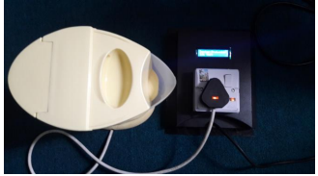

Figure 4.1: Photograph of the protective device when load is connected.

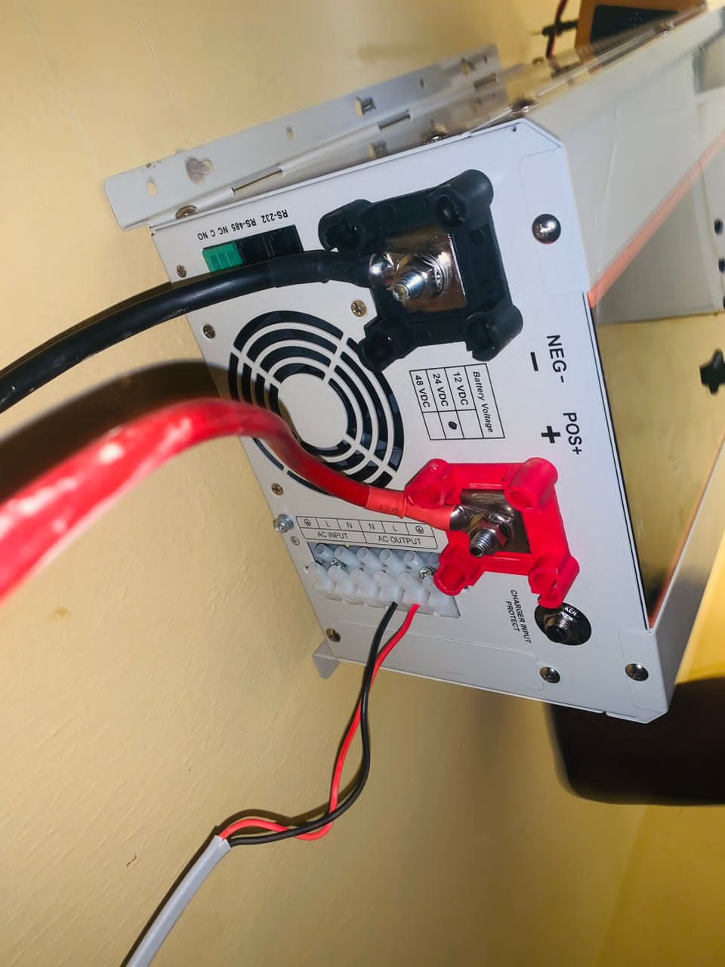

Figure 4.2: Installation of Solar Inverter

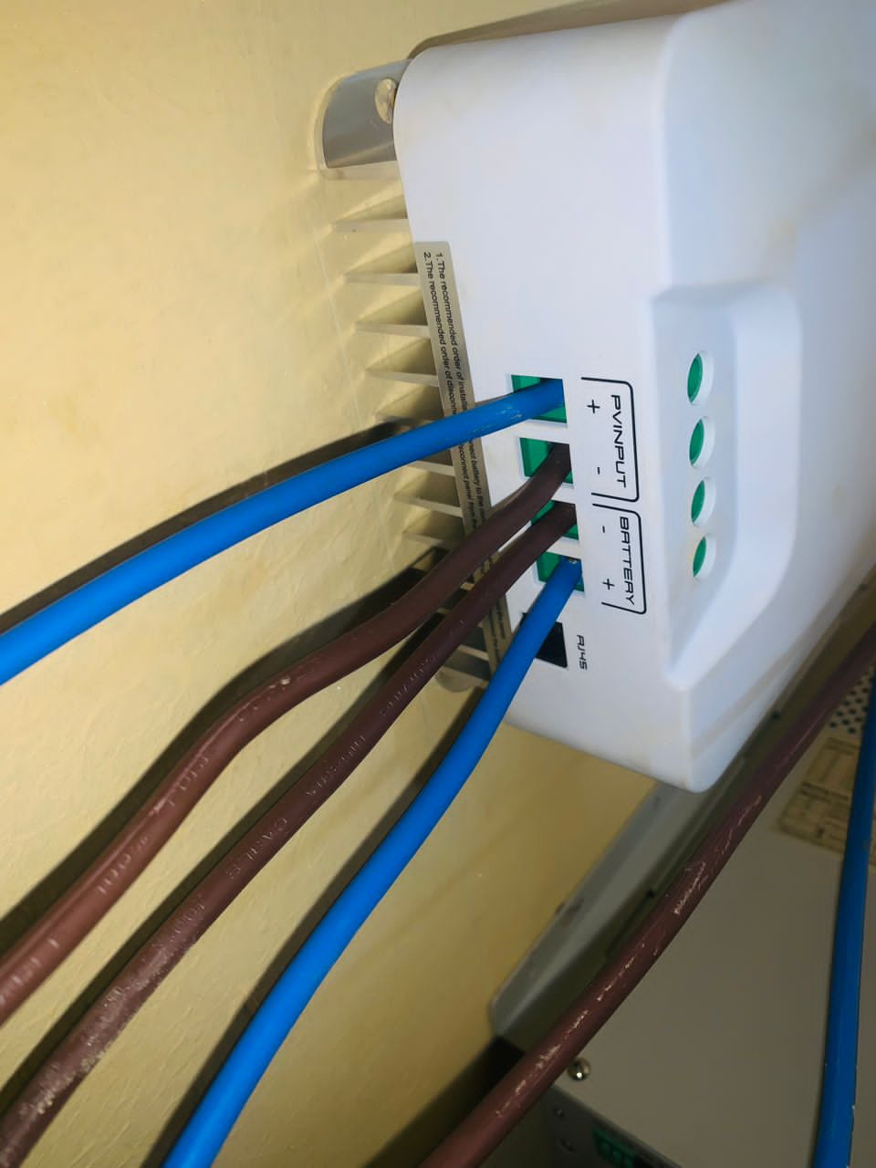

Figure 4.3: Connecting the Charge Controller

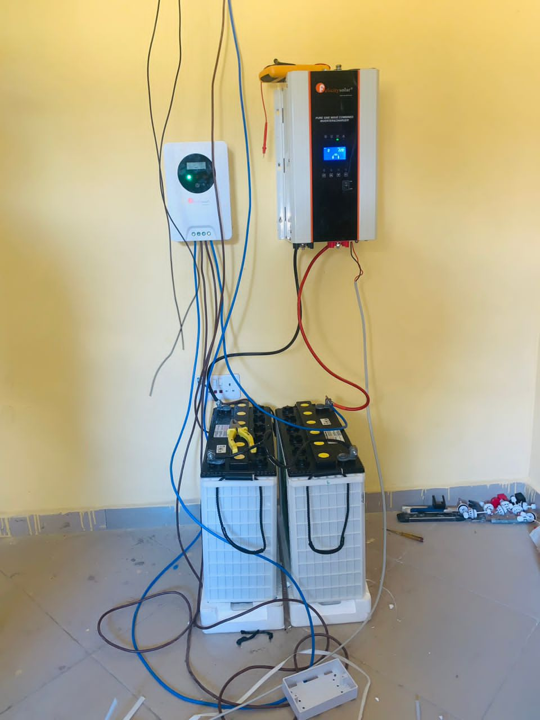

Figure 4.4: Complete Solar Energy System

**4.3 Discussion of Results**

The circuit was tested using a variac to vary power within the project scope. The output was connected to a relay, which controlled a lamp. When supply voltage dropped below 150V, the relay switched to its normally closed position, providing under-voltage protection. When supply voltage exceeded 240V, the relay tripped to its normally open position, ensuring overvoltage protection. The circuit tested without irregularities, as the voltage was within the typical set limit of 200V to 240V. The addition of a protection mechanism prevented overvoltage in the solar inverter circuit.

**CHAPTER FIVE**

**CONCLUSION AND RECOMMENDATIONS**

**5.1 Conclusion**

This project worked on the development of protection mechanisms for solar systems against overvoltage. It emphasized the importance of developing protection mechanisms for solar inverters to enhance the longevity, efficiency, and safety of both the inverter and the overall solar power system. Overvoltage conditions, which can result from factors such as lightning strikes, grid disturbances, or internal faults within the inverter, pose significant risks to electrical components. Without proper protection, these incidents can lead to equipment damage, reduced system performance, and safety hazards.

This project detailed the design, testing, and implementation of a protection mechanism for solar inverters against overvoltage. The resulting device is a reliable and practical solution for improving the quality of power supply to household appliances while ensuring their safety.

**5.2 Recommendations**

The following are recommended

1. The system can be enhanced by integrating smart circuit breakers or digital relays that offer faster and more precise short-circuit detection.
2. Future research can integrate SMS feedback system to monitor the performance of the system.

**REFERENCES**

Akbarzadeh, A. and Wadowski, T. (2014). Solar photovoltaic systems and their applications. Energy Sources, 6(2), 113-127. doi:10.1080/00139307.2014.892121.

Akbarzadeh, A. and Wadowski, T. (2014). Solar photovoltaic systems and their applications. Energy Sources, 6(2), 113-127.

Alaboudy, A. (2019). Sustained overvoltage in distribution networks and transformer protection strategies. International Journal of Electrical Power & Energy Systems.

Al-Sumaiti, A. (2021). Surge protection in photovoltaic systems: An overview of current practices and recommendations. Renewable Energy Journal.

Alumona, T. L., Nwalozie, G. C., Ufoaroh, S. U. and Alade, T. A. (2016). Design and Construction of an RF Remote Control 5kva Inverter System.International Journal of Computer Science and Mobile Computing.5(4). 570-583

Apeh S. T. and Olaye, E. (2015). Design and Construction of A 5kva Power Inverter with Real Time Automated Power Consumption Management System. African Journal of Computing & ICT.8(2), 203-215

Dai, Z. and Chen, L. (2021). Resonance-induced overvoltage in power systems: Causes and countermeasures. Electrical Engineering and Control Systems Journal.

Erol-Kantarci, M. and Mouftah, H. T. (2011) “Wireless Sensor Networks for CostEfficient Residential Energy Management in the Smart Grid. IEEE Transactions on Smart Grid.2(2), 314-325.

Ghorbani, A. (2023). Hybrid protection mechanisms in solar photovoltaic systems with machine learning capabilities. IEEE Transactions on Smart Grid.

Guerriero, P., & Rossi, M. (2020). Comparative study of power optimizers and microinverters in solar PV systems. Energy Procedia, 138, 705-712.

Hantila, F. and Popescu, F. (2016). Power electronics in renewable energy systems. Renewable Energy Research, 23(3), 341-352.

Hasan, W. and Decker, T. (2018). Performance analysis of central inverters in large-scale PV systems. IEEE Transactions on Industrial Electronics, 65(4), 2636-2643.

Khan, F. A. and Saeed, M. A. (2019). String inverters in grid-connected photovoltaic systems: A comparative review. Journal of Renewable Energy Research, 7(4), 1113-1120.

Li, Z. and Ma, Y. (2021). Hybrid inverters for solar PV and energy storage systems: Review and future trends. Journal of Energy Storage, 38, 102496.

Liang, H. and Chen, Y. (2022). Microgrid resilience in PV applications with adaptive overvoltage protection devices. Solar Energy Materials & Solar Cells.

Messenger, R. A and Ventre, J. (2004), Photovoltaic Systems Engineering, Second Edition, pp 190-245

Mohammadi, A. (2022). Overvoltage effects on photovoltaic systems and mitigation approaches. Renewable Energy and Sustainable Energy Reviews.

Morales-Espana, G. (2020). Grid-connected solar farms and transient overvoltage: Challenges and solutions. IEEE Transactions on Energy Conversion.

Mujtaba, G., Li, C. and Khan, F. A. (2021). Solar inverter technologies for photovoltaic applications: A review. Journal of Renewable and Sustainable Energy, 10(4), 041301.

Rao, K. S. and Banerjee, P. (2017). Advanced power electronics for solar applications. Journal of Power Electronics and Systems, 5(3), 210-218.

Singh, R., Sharma, P. and Garg, S. (2019). Application of arc-fault circuit interrupters in photovoltaic systems. International Journal of Power Systems Research, 11(3), 280-295.

Tang, Y. (2021). Advances in surge protection devices for renewable energy applications. IEEE Transactions on Smart Grid.

Theraja, A. K. and Theraja, B. L. (2005).Electrical Technology.Multicolor Edition. S Chand And Company Ltd, Ram Magar, New Delhi, 1116 -1123

Villalva, M. G. (2019). Comprehensive Approach to Modeling and Simulation of Photovoltaic Arrays. IEEE Transactions on Power Electronics.

Wang, Y. and Zhang, Z. (2020). Grid-connected photovoltaic inverter system. International Journal of Electrical Power & Energy Systems, 123(1), 106-118. Allied Market Research. (2021). Solar inverter market: Global opportunity analysis and industry forecast, 2021–2028. Retrieved from https://www.alliedmarketresearch.com

Woyte, A. and Nijs, J. (2017). Microinverter technology in solar photovoltaic systems: A comparative study. Solar Energy Materials & Solar Cells, 93(2), 157-165.

Wu, X (2020). Lightning-induced transient overvoltage on transmission lines and mitigation techniques. IEEE Transactions on Power Delivery.

Zhang, W. and Li, F. (2019). Relay-based protection schemes for off-grid solar systems under overvoltage conditions. International Journal of Renewable Energy Research.